CHAPTER 14 BITMAPS AND BITBLTS

Unveiling the World of Bitmaps and Bitblts in Windows

This chapter dives into the fascinating realm of bitmaps and bitblts, essential tools for manipulating and displaying images in Windows applications. Let's embark on a journey through their intricate workings:

What are Bitmaps?

Imagine a rectangular grid overlaid on an image. Each tiny square within this grid represents a pixel, the basic unit of visual information.

A bitmap, in its simplest form, is a two-dimensional array of bits corresponding to these pixels. Each bit value determines the pixel's color or intensity, with 1 representing "on" and 0 representing "off."

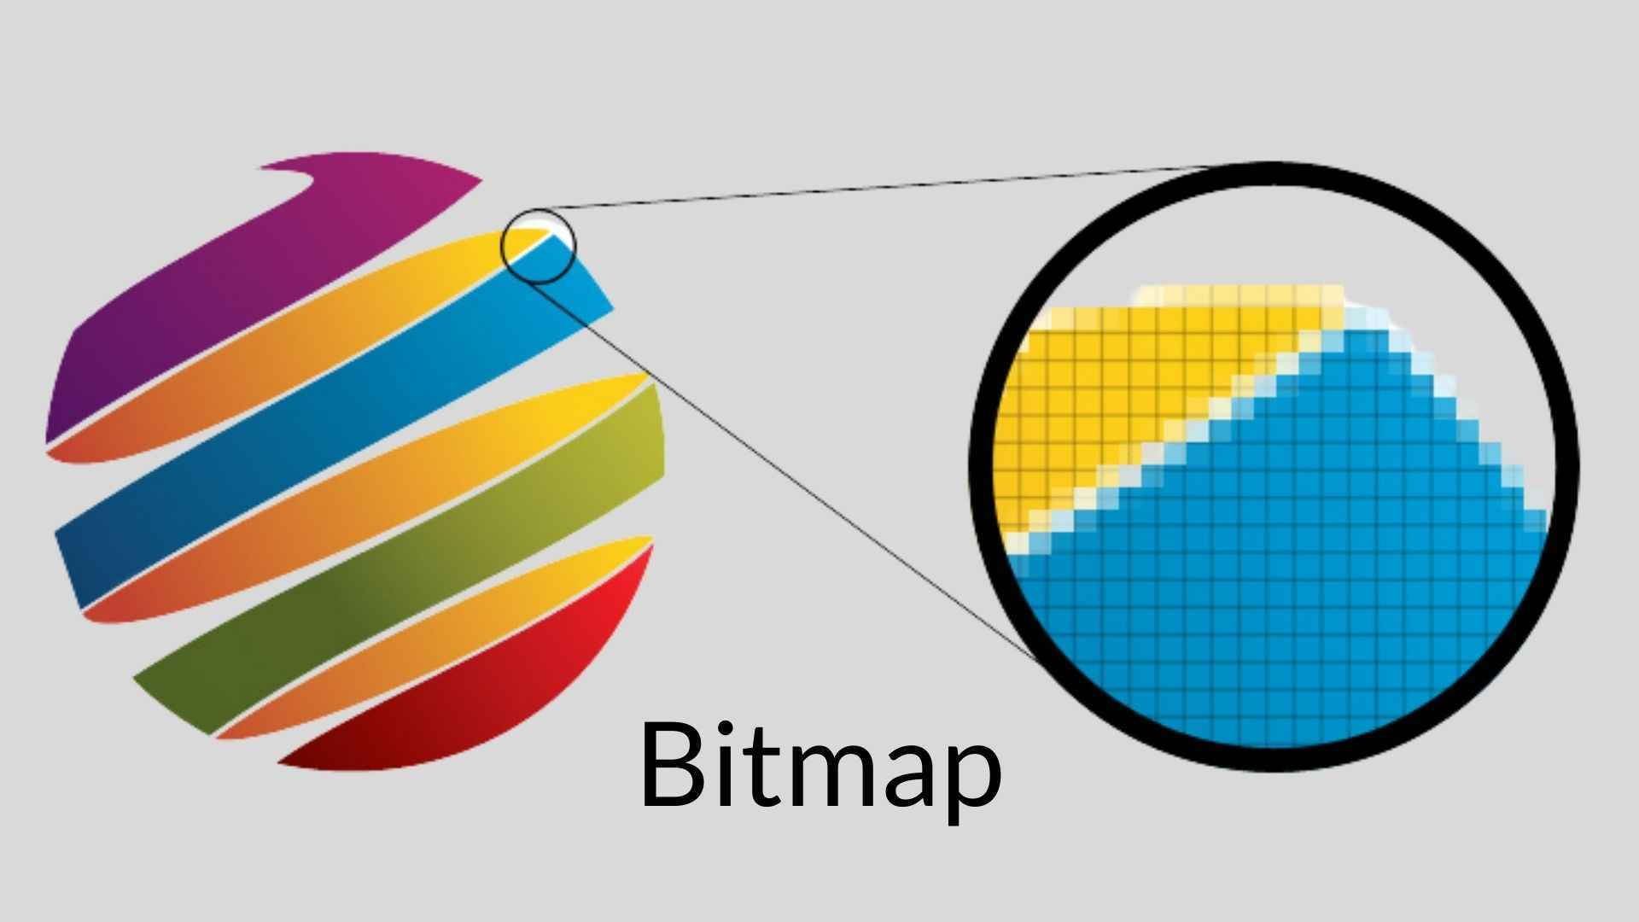

Shades and Colors: Beyond Binary

While monochrome bitmaps require just one bit per pixel, the world of images is often richer than black and white.

For shades of gray or vibrant colors, multiple bits per pixel come into play. Each bit acts as a tiny brushstroke, contributing to the overall color palette.

Think of it as a mosaic, where combinations of these individual bits build the intricate tapestry of the image.

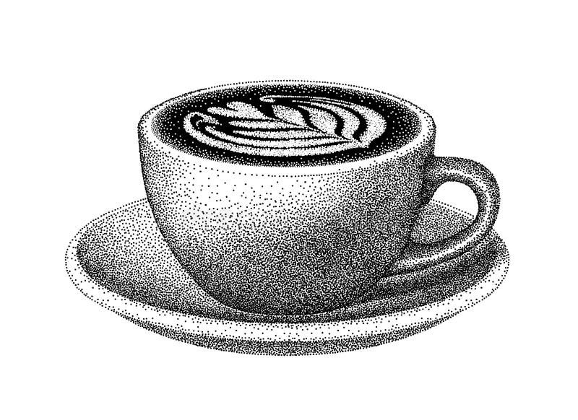

Bitmaps vs. Metafiles: Two Approaches to Pictorial Data

Windows offers two main approaches to storing pictorial information:

Bitmaps: As described above, bitmaps directly represent the digital image data, essentially a snapshot of the pixels and their colors. They are efficient for simple images but can become bulky for complex ones.

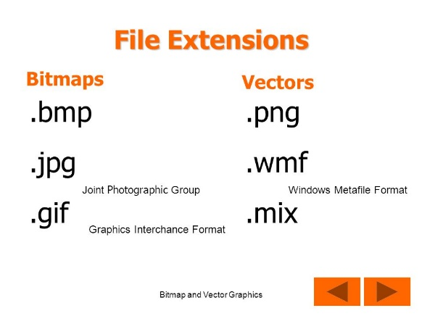 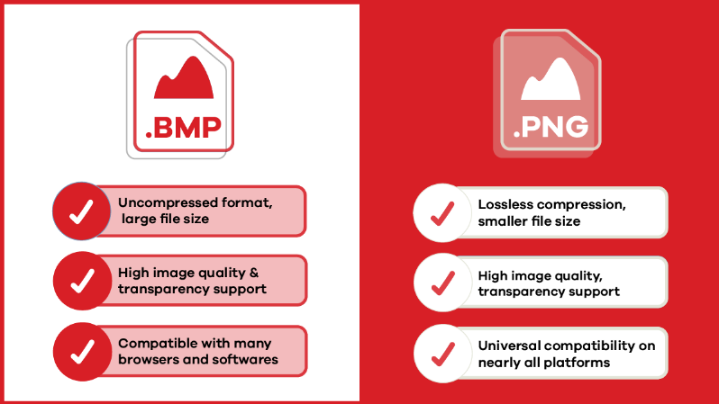

Metafiles: These store a set of instructions for drawing the image, similar to a recipe for creating the visual output. They are compact but require processing power to render the image on-screen.

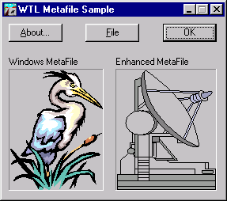

GDI Bitmaps: The Predecessors to DIBs

Before the introduction of device-independent bitmaps (DIBs) in Windows 3.0, GDI bitmaps reigned supreme. This chapter focuses on these pre-DIB bitmaps, showcasing their power and versatility even in the face of their later counterparts. Don't underestimate their value!

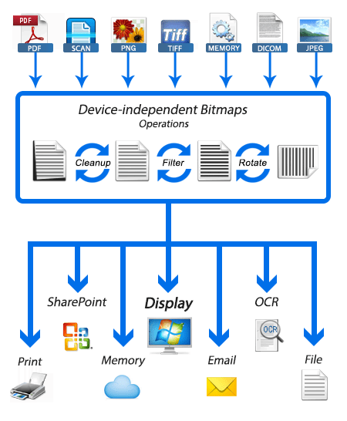

Bitblts: The Magic of Copying and Combining Images

Bitblts, short for bit block transfers, are the workhorses of image manipulation in Windows. They allow you to copy or combine rectangular regions of bitmaps, essentially transferring blocks of pixels from one location to another. Think of them as the paintbrushes and palettes of the digital world, enabling you to blend, move, and manipulate images with precision.

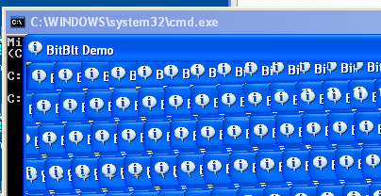

Exploring the Chapter's Depths:

Through a series of sample programs, this chapter delves deeper into the practical applications of GDI bitmaps and bitblts. You'll learn how to:

* Create and manipulate bitmaps using GDI functions.
* Load and display images from various formats like BMP and ICO.
* Copy and move portions of images using bitblts.
* Combine multiple images into a single composition.
* Apply transparency effects to create layered visuals.

Beyond the Basics:

This chapter lays the foundation for further exploration. You can dive deeper into topics like:

* Advanced bitblt operations for sophisticated image manipulation.
* Optimizing bitmap performance for efficient memory usage.
* Leveraging DIBs for device-independent image handling.

Embrace the Power of Bitmaps and Bitblts:

By understanding the concepts presented in this chapter, you unlock a powerful toolset for creating visually compelling applications in Windows. Remember, bitmaps and bitblts are not relics of the past; they remain valuable building blocks for modern image-centric applications. So, grab your digital paintbrush and start exploring the boundless possibilities of these fascinating tools!

DELVING DEEP INTO BITMAPS AND METAFILES: UNVEILING THEIR STRENGTHS AND WEAKNESSES

The digital world of images thrives on two distinct approaches: bitmaps and metafiles. Each holds its own advantages and drawbacks, shaping the way we create, manipulate, and share visual information. Let's dive deeper into their characteristics to understand their unique strengths and weaknesses:

Bitmaps: Capturing the Nuances of the Real World

Direct Representation: Imagine a detailed photograph. A bitmap captures it by meticulously recording the color or intensity of each tiny pixel, creating a digital replica of the real world with remarkable accuracy. This makes them ideal for complex images like scanned documents, photographs, and video captures.



Device Dependence: However, bitmaps come with a caveat – their close ties to specific devices. Colors might appear washed out on a monochrome display, and scaling often leads to distortion due to pixel manipulation.

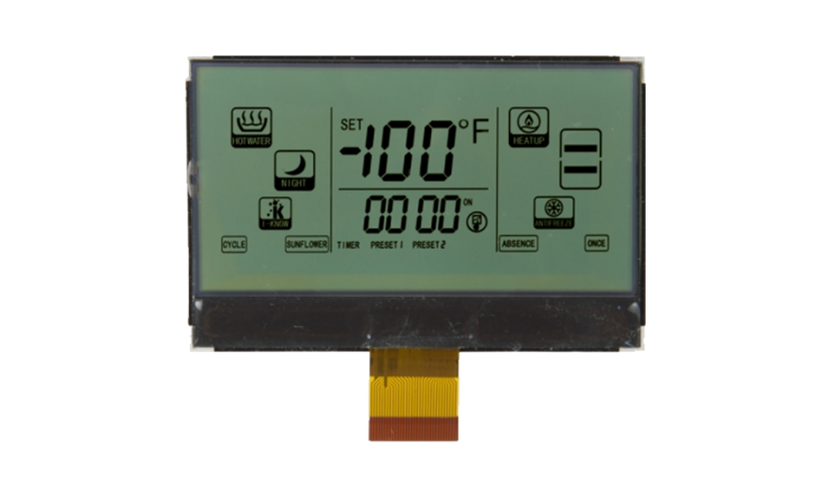

Storage Demands: The sheer amount of data required to represent every pixel can be substantial. A high-resolution image can easily consume megabytes of storage, posing challenges for transmission and archiving.



Metafiles: A Recipe for Scalability and Flexibility

Instructions, not Pixels: Unlike bitmaps, metafiles don't store the actual image data. Instead, they act like recipes, containing a series of instructions for drawing lines, shapes, and fills. This offers several advantages:

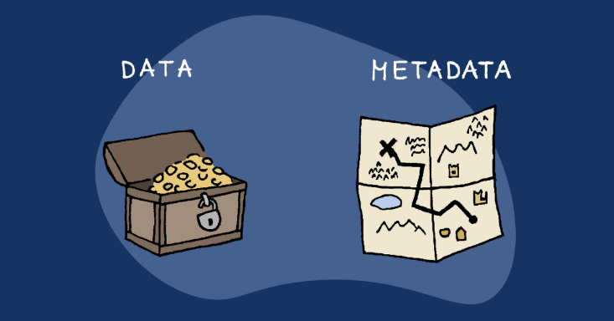

Device Independence: Metafiles can adapt to different devices and resolutions without distortion. The "recipe" adjusts automatically, ensuring consistent appearance across various displays and printers.

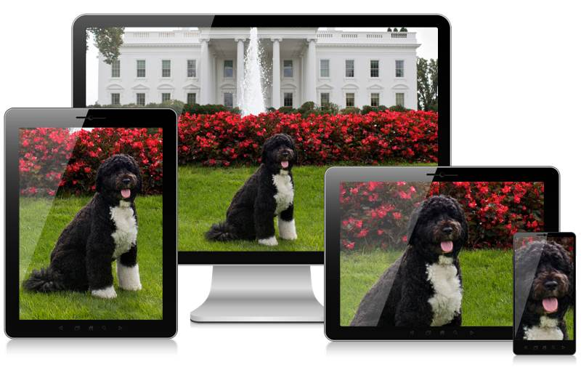

Scalability: Need a bigger image? Metafiles can be scaled up or down seamlessly without compromising quality, making them perfect for architectural drawings and diagrams.

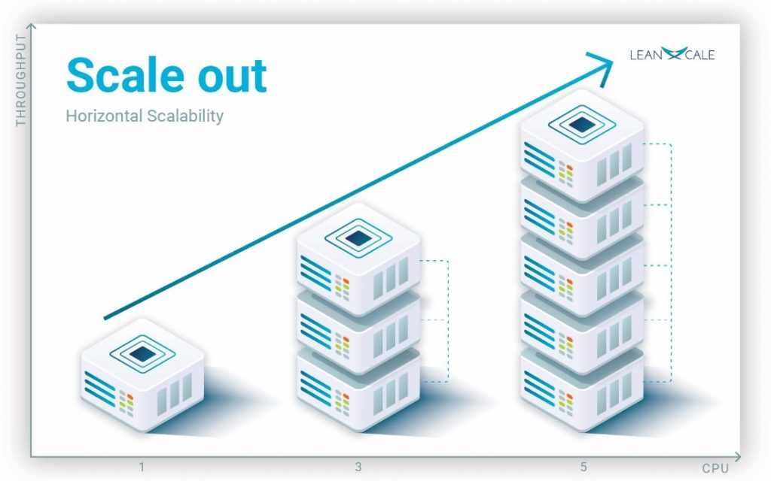

Compact Size: Compared to bitmaps, metafiles often require significantly less storage space. The instructions themselves are relatively small, making them ideal for sharing and transmission.

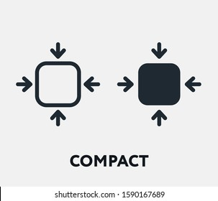

The Trade-off: Speed vs. Complexity

Speed Demon: When it comes to displaying simple images, bitmaps reign supreme. Copying a bitmap to the screen is a quick and efficient process, making them ideal for fast-paced applications like games and animations.



Processing Power: Metafiles, on the other hand, require more processing power to interpret their instructions and translate them into actual pixels. This can lead to slower rendering, especially for complex images.

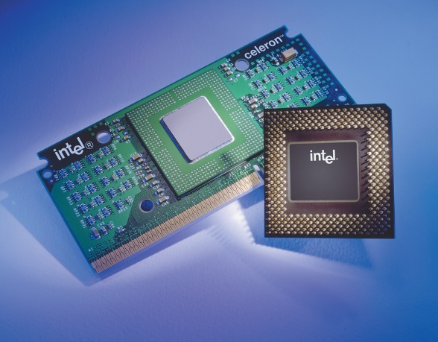

Beyond the Basics: Compression and Evolution

Compression Techniques: The storage demands of bitmaps have been addressed by compression algorithms. These algorithms can significantly reduce file size without sacrificing image quality, making bitmaps more manageable for transmission and storage.

DIBs and Beyond: The world of bitmaps continues to evolve. Device-independent bitmaps (DIBs) offer enhanced flexibility and device independence, while more advanced formats like JPEG and PNG provide efficient compression for various image types.

Choosing the Right Tool for the Job:

Understanding the strengths and weaknesses of both bitmaps and metafiles empowers you to make informed decisions about which approach to use. Consider factors like:

* Image Complexity: For intricate real-world images, bitmaps offer unmatched detail.
* Scalability and Flexibility: Metafiles shine when consistent appearance and adaptability are key.
* Storage and Transmission: If file size is a concern, metafiles generally take up less space.
* Performance: For fast-paced applications, the speed of bitmaps might be crucial.

Conclusion:

Bitmaps and metafiles are not rivals, but complementary tools in the digital artist's toolbox. Understanding their unique strengths and limitations allows you to leverage their power to create visually stunning and effective applications. So, choose wisely, experiment creatively, and let your imagination take flight in the world of digital images!



I hope this more in-depth explanation clarifies the differences and nuances between bitmaps and metafiles. Feel free to ask further questions or request specific aspects for deeper exploration! Remember, there's always more to discover in the fascinating world of computer graphics.

THE DIVERSE ORIGINS OF BITMAPS: A JOURNEY FROM MANUAL CREATION TO CAPTURED REALITY

Bitmaps, those ubiquitous building blocks of digital images, have a fascinating journey before they grace our screens. Their origins lie not only in the creative minds of artists but also in the intricate workings of hardware and the wonders of the real world. Let's delve into the diverse ways bitmaps come to life:

1. From the Artist's Brush to the Digital Canvas:

Manual Creation: Programs like Paint allow artists to directly create bitmaps. Each brushstroke, each pixel placed, becomes part of the final image. This approach is ideal for intricate details and artistic expression, where precise control over individual pixels is paramount.



2. Algorithmic Magic:

Code-Crafted Images: Not all bitmaps need a human touch. Computer code can generate intricate patterns, textures, and even fractals, often too complex to be rendered as vectors. These algorithmically generated landscapes and abstract creations push the boundaries of digital art.

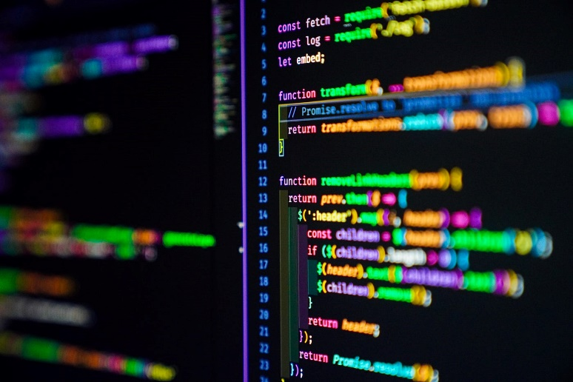

3. Capturing the Real World:

Hardware Heroes: This is where bitmaps truly shine, capturing the essence of the physical world. Hardware devices like scanners, camcorders, and digital cameras bridge the gap between reality and the digital realm.

Scanners: The veterans of the field, scanners use rows of CCD (charge-coupled device) cells to scan images, translating light intensity into electrical charges, then into digital values. With each scan, a line of pixels is captured, building the final bitmap representation of the scanned image.

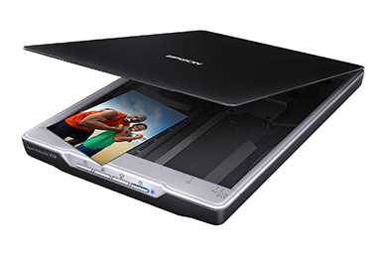

Camcorders: These video capture devices employ CCD arrays to capture video frames, which can be stored on tape or, more recently, converted directly into bitmaps using video frame grabbers. This allows you to grab individual frames from videos, creating still images from your favorite movies or TV shows.

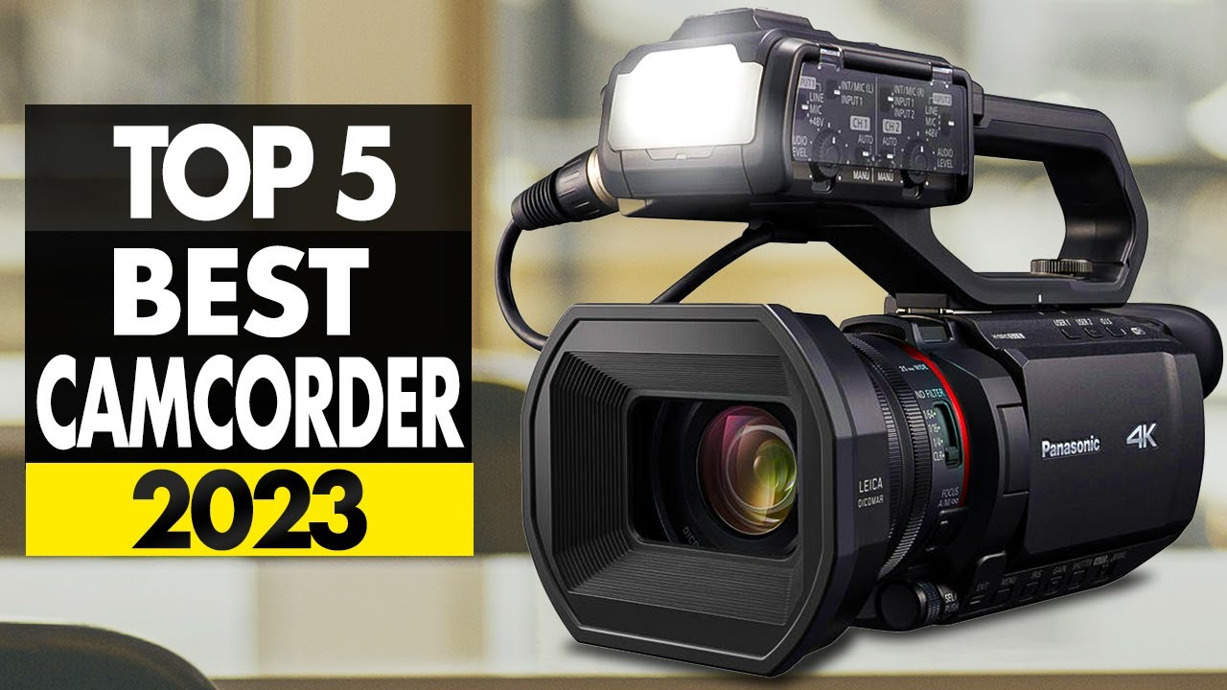

Digital Cameras: The latest stars of the show, digital cameras have made capturing bitmaps accessible and affordable. Their internal CCD arrays and ADCs convert light directly into digital images, stored within the camera itself. These images can then be transferred to computers for editing, sharing, and creative exploration.

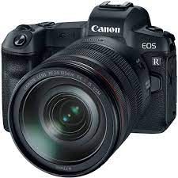

Beyond the Basics:

Beyond CCDs: While CCDs are the dominant technology, other sensors like CMOS (complementary metal-oxide-semiconductor) are also used in image capture devices.

Image Compression: The quest for efficient storage has led to various compression algorithms that reduce bitmap file size without sacrificing significant image quality.

The Future of Bitmaps: As technology advances, expect even higher resolutions, faster capture speeds, and even more sophisticated algorithms for generating and manipulating bitmaps.

Conclusion:

* Bitmaps are not just pixels on a screen; they represent diverse creative expressions, captured moments from the real world, and the ever-evolving landscape of digital imaging technology.
* So, the next time you encounter a bitmap, take a moment to ponder its journey – from the artist's canvas, the intricate workings of a scanner, or the fleeting moment captured by a camera lens.
* Each bitmap tells a story, a testament to the creative power of humans and the ever-evolving world of digital imagery.

DEMYSTIFYING BITMAP DIMENSIONS: A DEEP DIVE INTO WIDTH, HEIGHT, AND COORDINATES

When it comes to bitmaps, understanding their dimensions is crucial. It's the foundation upon which their visual information rests, dictating their size, resolution, and even interaction with other elements. Let's delve deeper into the fascinating world of bitmap dimensions:

Rectangular Wonders:

At their core, bitmaps are rectangular grids of pixels, each representing a tiny dot of color or intensity. This grid defines the image's spatial dimension, measured in pixels: width and height.

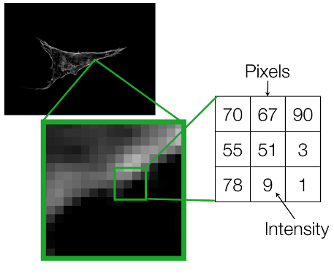

Shorthand Notation:

To avoid cumbersome phrases, we often use a concise notation for a bitmap's dimensions. For instance, "9 by 6" describes a bitmap 9 pixels wide and 6 pixels high. Remember, the width comes first by convention.

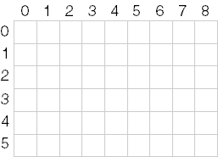

Pixel Power:

The total number of pixels in a bitmap is calculated by multiplying its width and height. In our example, 9 pixels x 6 pixels = 54 pixels. We often use cx and cy (count x and count y) to represent width and height, respectively.

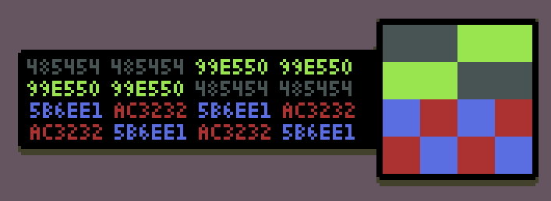

Coordinates: Pinpointing Pixels:

Each pixel within a bitmap holds its own unique location, identified by its x and y coordinates. By convention, the upper left corner is considered the origin (0, 0). Following this system, the bottom right pixel in our 9x6 example would be located at (8, 5) – one less than the width and height because numbering starts at zero.

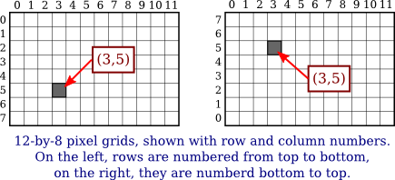

Resolution: A Confusing Term:

The term "resolution" can be tricky when discussing bitmaps. It can refer to both:

* Display Resolution: This refers to the number of pixels a display device like a monitor can show, often expressed as "640x480".
* Pixel Density: This refers to the number of pixels per unit of measurement, like "300 dots per inch" for a printer.

For bitmaps, focusing on pixel density as "resolution" provides a clearer understanding of their detail level.

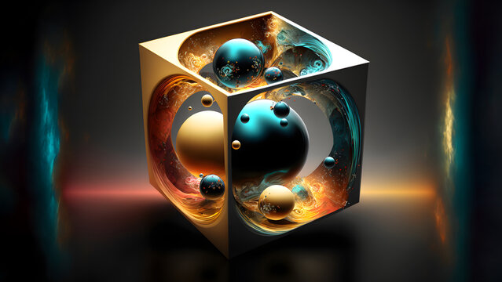

Memory Maze: Storing Bitmaps Linearly:

While bitmaps are rectangular, our computers store information linearly. Therefore, bitmaps are typically stored in memory row by row, starting with the top row and ending with the bottom. Each row, in turn, stores pixels from left to right, mimicking how we write lines of text.

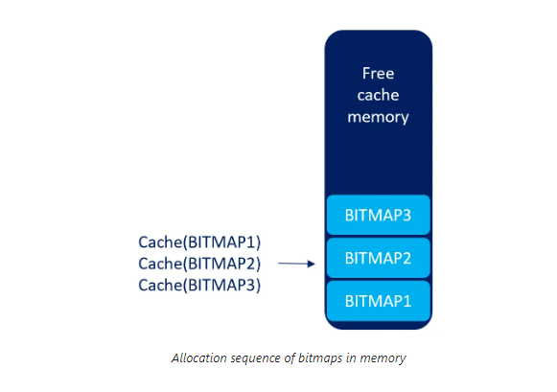

The Exception: DIBs and Beyond:

It's important to note that not all bitmaps conform to this linear storage model. Device-independent bitmaps (DIBs), for instance, store information differently, offering greater flexibility and device independence.

Understanding Dimensions: A Key to Success:

Grasping a bitmap's dimensions is essential for various tasks:

Scaling and manipulating images: Knowing the width and height allows for proper resizing and adjustments without distortion.

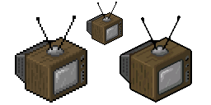

Extracting specific pixels: Coordinates enable access and manipulation of individual pixels within the bitmap.

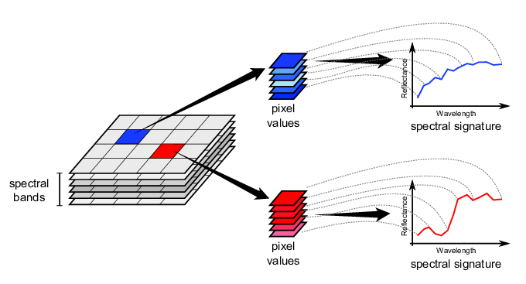

Aligning with other elements: Understanding dimensions becomes crucial when placing bitmaps alongside other visual elements within an application or user interface.

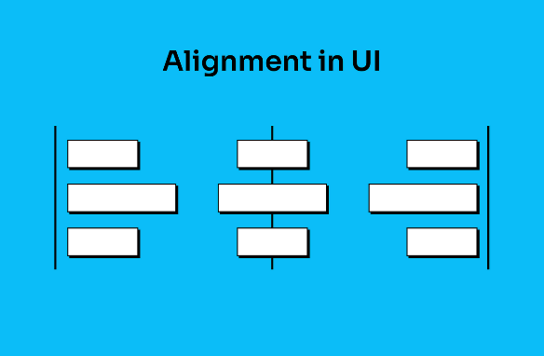

UNVEILING THE MYSTERY OF COLOR IN BITMAPS: A DEEP DIVE INTO BIT DEPTHS AND PALETTE MAGIC

Beyond their width and height, bitmaps possess another crucial dimension – color. This dimension, defined by the number of bits allocated to each pixel, determines the richness and complexity of the visual information they can display. Let's explore the fascinating world of color within bitmaps:

Bit Depth: The Language of Color:

Each pixel in a bitmap speaks the language of bits. The number of bits assigned to it, known as the bit depth or color depth, determines how much color information it can carry. This depth acts like a vocabulary, defining the range of colors a pixel can express.

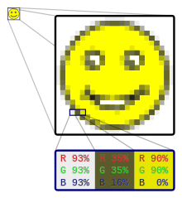

Monochrome Masters: Bilevel and Beyond:

At the simplest level, a bitmap can have just one bit per pixel, making it a "bilevel" or "monochrome" image.

This binary world allows only two states: on (typically white) or off (typically black). While seemingly limited, these monochrome masters excel in sharp lines, intricate patterns, and classic artistic expressions.

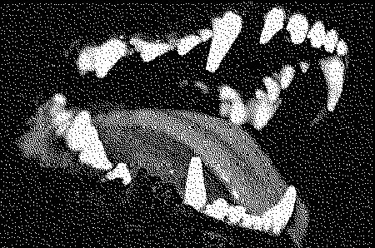

Beyond Black and White: Expanding the Palette:

With more bits come more colors. Each additional bit doubles the potential color combinations, opening doors to a richer palette. Two bits offer four colors, four bits offer sixteen, and so on. This exponential growth allows bitmaps to paint a broader spectrum of the world around us.

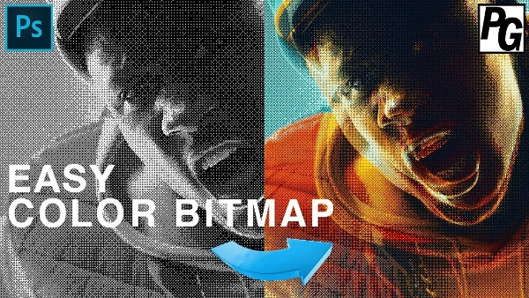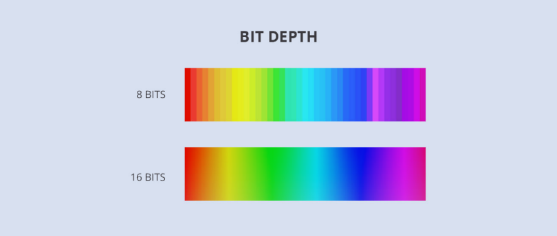

The Magic of 8-bit Palettes: A Familiar Canvas:

For decades, the 8-bit world reigned supreme in digital art and early computing. With 256 possible colors, it struck a balance between complexity and practicality. Artists crafted vibrant palettes, each pixel carefully chosen to depict landscapes, characters, and objects in a captivatingly pixelated style.

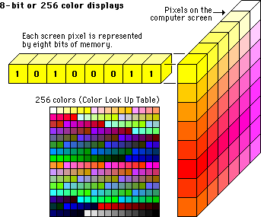

Pushing the Boundaries: 16-bit, 24-bit, and Beyond:

The quest for photographic realism led to higher bit depths. 16-bit bitmaps offered a staggering 65,536 colors, while 24-bit bitmaps, the standard for modern displays, boast a mind-boggling 16.7 million colors! This vast palette allows for near-photorealistic images, blurring the line between the digital and the real.

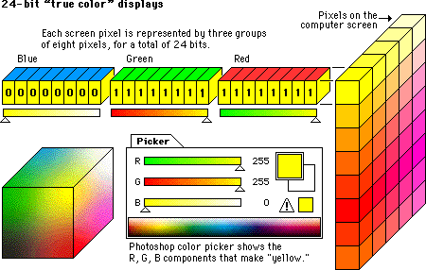

Decoding the Color Code: From Bits to Familiar Hues:

But how do these bits translate into actual colors? This is where the magic of color mapping comes into play. Each combination of bits corresponds to a specific index in a palette, a collection of pre-defined colors.

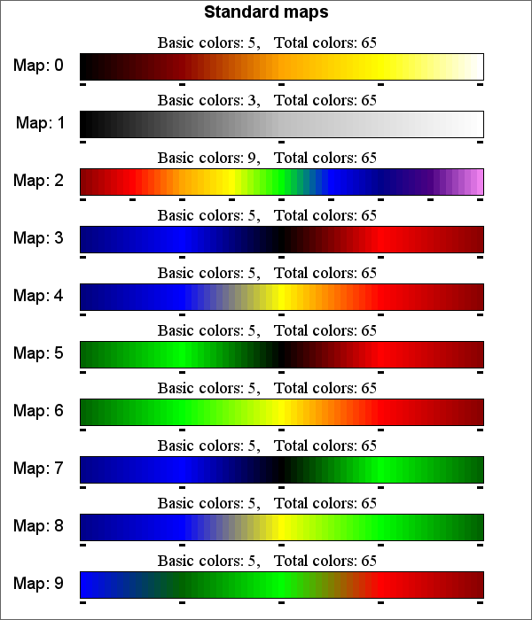

The operating system or application maintains this palette, and the bitmap simply references the indexes to paint its pixels. Understanding this mapping system empowers you to manipulate palettes, create custom color worlds, and inject your own artistic vision into your bitmaps.

Beyond the Basics: Dithering, Transparency, and More:

The world of color in bitmaps is vast and ever-evolving. Techniques like dithering simulate additional colors with limited bit depths, while transparency allows bitmaps to blend seamlessly with other visual elements. The possibilities are as limitless as your imagination.

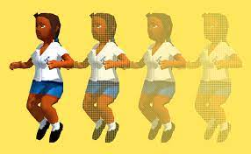

Color in bitmaps is more than just a technical specification; it's a language, a tool, and a canvas for artistic expression.

By understanding the intricacies of bit depths, palettes, and mapping techniques, you unlock the potential to create stunning visuals, tell stories with pixels, and push the boundaries of digital art. So, grab your digital brush, delve deeper into the world of color, and let your creativity flow!

Let’s goo….!!

DEMYSTIFYING BITMAPS AND REAL-WORLD DEVICES: A DIVE INTO COLOR DEPTHS AND HISTORICAL CONTEXT

The world of bitmaps is not just a realm of pixels and numbers; it's also deeply intertwined with the evolution of computer hardware and visual display technology. Let's take a deep dive into how real-world devices influenced bitmap formats and color capabilities throughout Windows history.

From Monochrome to Multicolor: A Journey through Video Display Adapters:

Monochrome Masters: In the early days of Windows, the Hercules Graphics Card (HGC) reigned supreme as the monochrome champion.

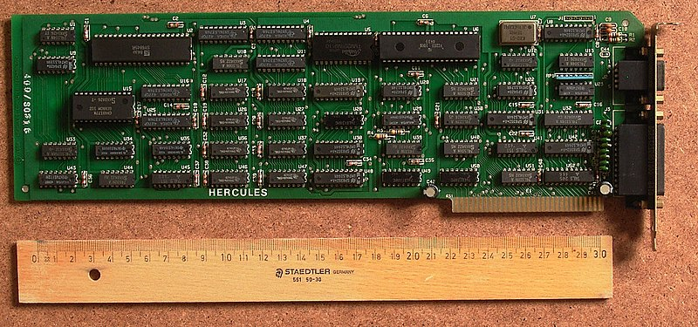

Its bitmaps, with only one bit per pixel, displayed stark black and white images, but they were perfect for text-based applications and laid the foundation for future advancements.

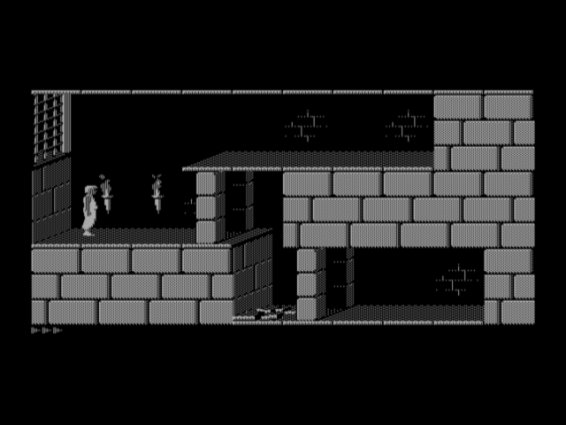

EGA, Embracing 16 Colors: The Enhanced Graphics Adapter (EGA) marked a pivotal moment, introducing 16 color capabilities to Windows users. Each pixel now held 4 bits of color information, allowing for basic representations of red, green, and blue alongside their darker and lighter shades. This palette, now considered the minimum standard for Windows, became the foundation for iconic Windows elements like mouse cursors and simple cartoon-like images.

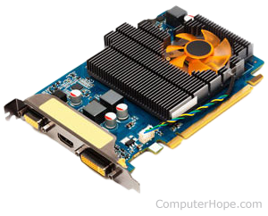

IRGB Encoding: A Legacy from Character Modes: The color encoding used in 16-bit bitmaps, known as IRGB (Intensity-Red-Green-Blue), actually originated from the IBM CGA's character mode colors. This system assigned 4 bits to each pixel, mapped in a specific way to the familiar hexadecimal RGB values used by Windows.

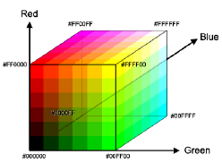

Beyond 16 Colors, A Spectrum of Possibilities:

While 16-color bitmaps hold historical significance and remain relevant for specific applications, the quest for richer visuals led to advancements in video display adapters:

VGA and Beyond: The Video Graphics Array (VGA) introduced an 8-bit color depth, offering a palette of 256 colors and enabling more complex images and vibrant artwork.

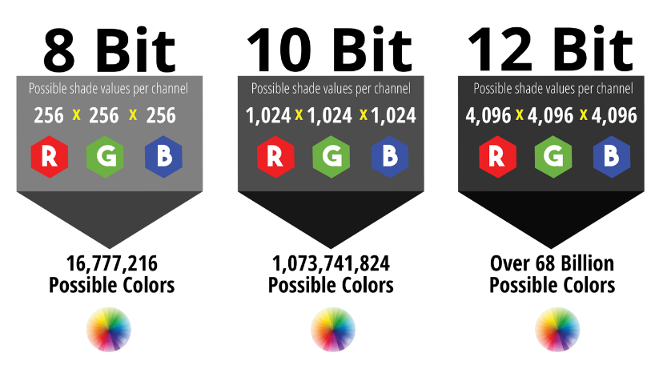

This further expanded the capabilities of Windows, opening doors to photorealistic graphics and detailed visual experiences.

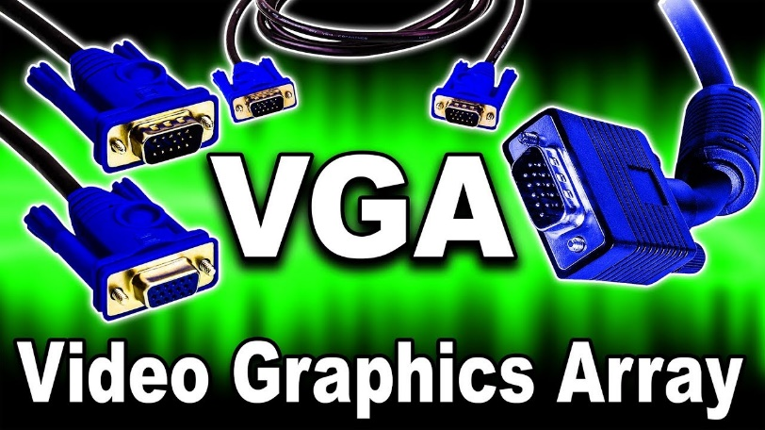

24-bit True Color: Embracing Millions of Hues: Today, with modern display adapters, we have 24-bit bitmaps, also known as True Color.

This format allocates 8 bits each for red, green, and blue, resulting in a staggering 16.7 million color combinations!

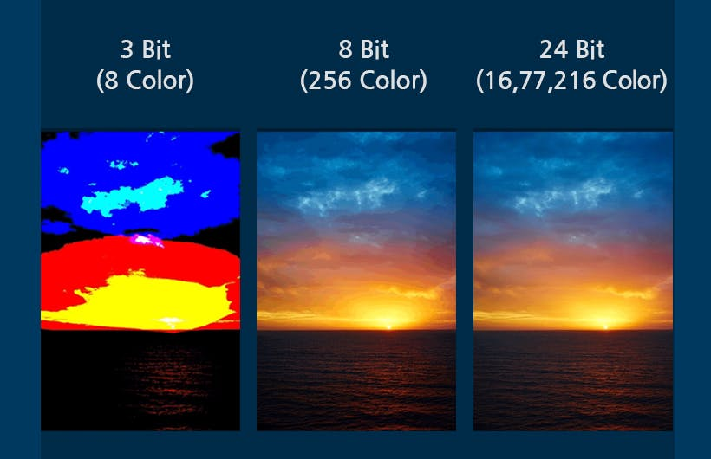

This allows for near-photorealistic visuals and unparalleled detail, blurring the line between the digital and the real.

Understanding the Connection:

By understanding how real-world devices like video display adapters influenced bitmap formats and color capabilities, we gain a deeper appreciation for the evolution of visual computing. This knowledge empowers us to:

Interpret historical visuals: Recognize the limitations and possibilities of older bitmap formats like 16-color IRGB encoding.

Choose the right format: Select the appropriate bitmap format based on the intended application, color requirements, and hardware compatibility.

Appreciate advancements: See the significant leaps in visual fidelity that have occurred with the development of new display technologies.

A Visual Guide:

To further solidify this understanding, consider this table summarizing the color depths discussed:

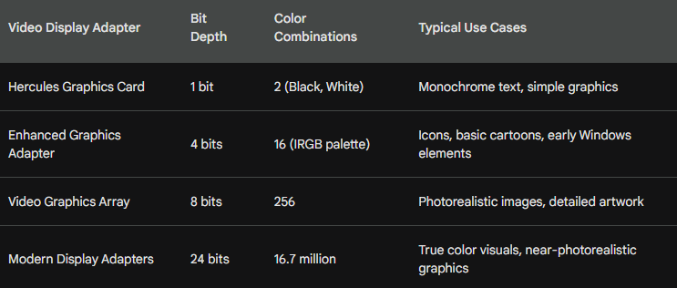

DELVING INTO THE COLORFUL WORLD OF VIDEO ADAPTERS AND BITMAPS: A DEEP DIVE

The world of bitmaps and their colors is more than just pixels and numbers; it's intimately intertwined with the evolution of video display adapters and the capabilities of different hardware configurations.

Let's embark on a deep dive into this fascinating realm, exploring the intricacies of color depths, memory organization, and the impact of historical hardware limitations.

16-Color IRGB: A Legacy from Character Modes:

While modern displays boast millions of colors, the early days of Windows relied on the humble 16-color palette.

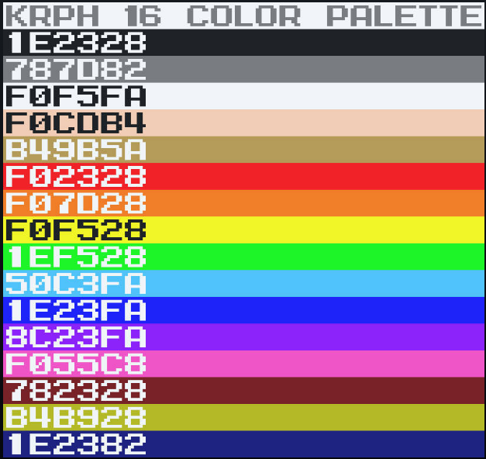 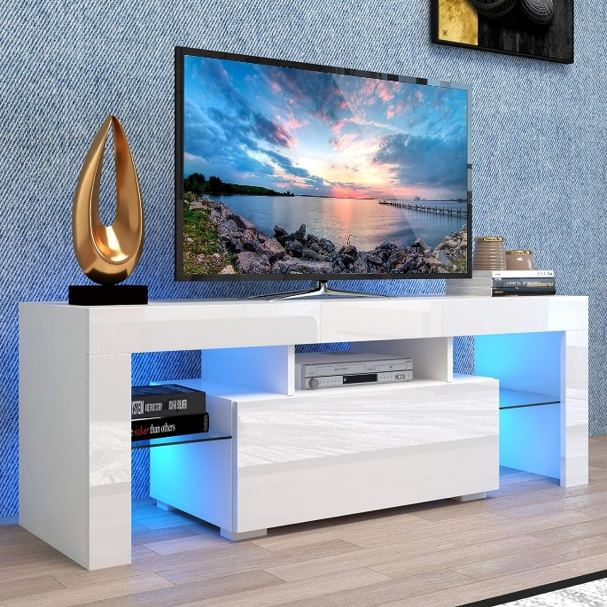

This limited spectrum, known as IRGB (Intensity-Red-Green-Blue), stemmed from the color limitations of the IBM CGA character mode.

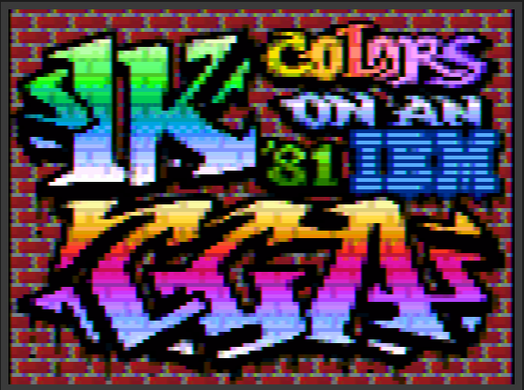

Each pixel was assigned 4 bits, mapped to specific hexadecimal RGB values as shown in the table below:

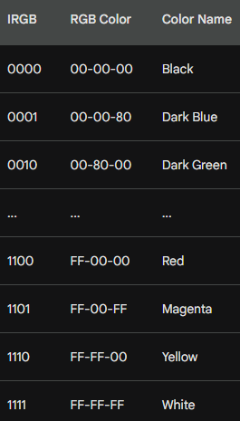

Memory Planes and Hardware Quirks:

The memory organization of the Enhanced Graphics Adapter (EGA) threw a curveball at programmers.

Instead of storing the four color bits consecutively for each pixel, the video memory was divided into separate "planes" for intensity, red, green, and blue.

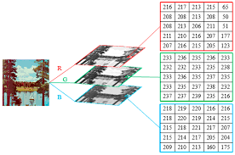

This device-specific quirk, thankfully, remained mostly hidden from Windows applications thanks to clever software handling.

From VGA to True Color, A Spectrum of Possibilities:

The limitations of 16 colors were soon overcome by the Video Graphics Array (VGA) in 1987.

This adapter offered a leap to 8 bits per pixel, allowing for a palette of 256 colors and unlocking the potential for more realistic visuals.

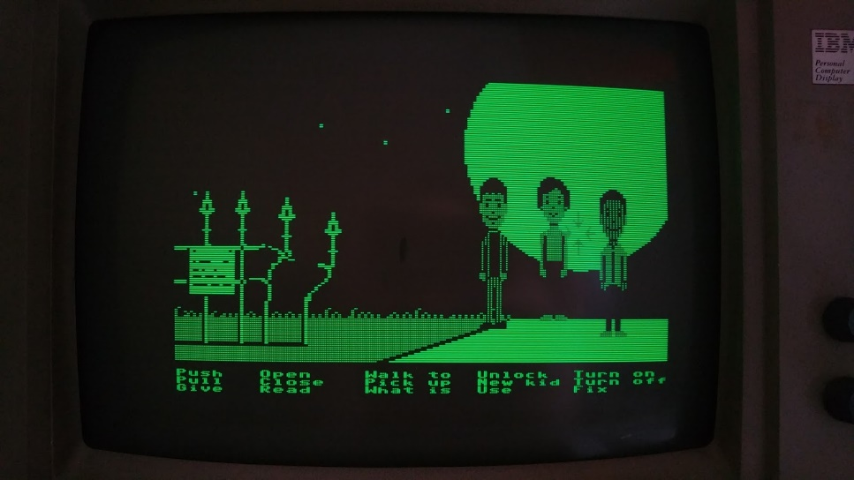

However, the original VGA required switching to a lower resolution mode for 256 colors, which wasn't ideal for Windows.

The arrival of Super-VGA (SVGA) adapters, with their standard 256-color support at 640x480 resolution, finally made this the norm.

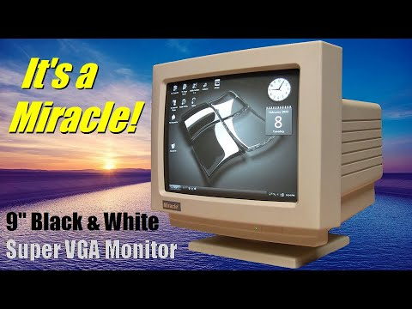

Palette Magic: Windows Takes Control:

While VGA offered 256 colors, Windows itself reserved 20 of them for system use. Applications accessed the remaining colors through the Windows Palette Manager, allowing them to customize and display real-world images effectively.

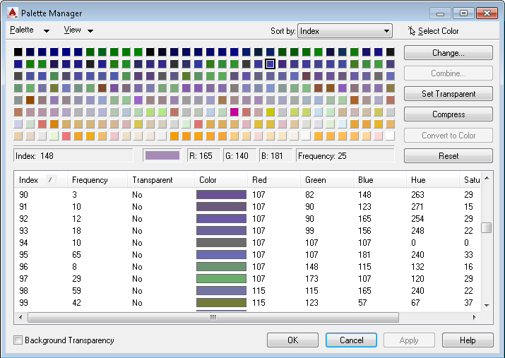

This table summarizes the reserved colors:

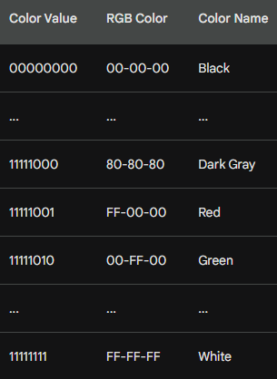

Moving Beyond the Limits: The Rise of High Color and True Color:

The quest for even greater visual fidelity led to the development of video adapters with 16 and 24 bits per pixel. These "high color" and "true color" adapters offered thousands and millions of colors, respectively, revolutionizing the way we experience visuals.

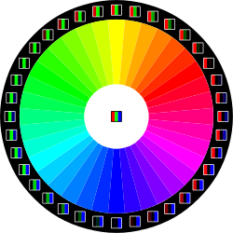

The 24-bit format, with its 3 bytes per pixel and ability to represent nearly the full spectrum of human perception, became the standard for years to come.

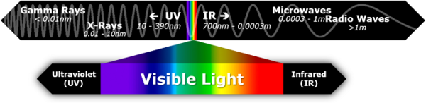

Understanding the Numbers, A Guide to Color Depths:

To navigate this colorful landscape, here's a quick reference table summarizing the discussed color depths and their characteristics:

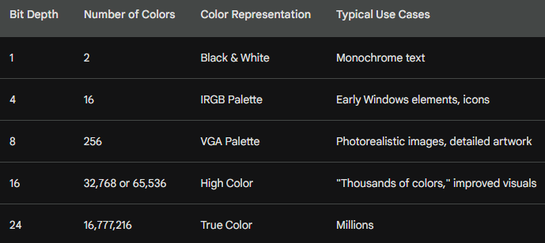

A DIVE INTO BITMAP SUPPORT IN GDI: FROM LEGACY TO MODERN MAGIC

The Windows Graphics Device Interface (GDI) has a long and fascinating history with bitmaps, spanning from its early days of monochrome displays to the vibrant world of millions of colors. Let's take a deep dive into this evolution, exploring the challenges and innovations that shaped bitmap support in GDI:

Early Days: GDI Bitmaps and Color Constraints:

In the pre-Windows 3.0 era, GDI bitmaps were purely tied to specific hardware limitations. These "GDI bitmap objects" existed as references tied to a display adapter's color capabilities.

Monochrome displays meant black and white bitmaps, and a 16-color VGA adapter restricted bitmaps to the IRGB palette. This limited flexibility, as bitmaps could not be readily moved between devices with differing color capabilities.

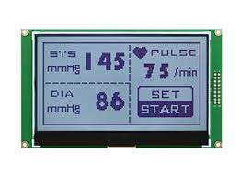

DIBs: Enter the Device-Independent Revolution:

Windows 3.0 marked a watershed moment with the introduction of Device-Independent Bitmaps (DIBs). These ingenious creations broke the chains of hardware limitations.



Each DIB carried its own color table, defining how pixel bits corresponded to actual RGB colors.

This allowed DIBs to be displayed on any raster output device, regardless of its native color organization. However, converting DIB colors to match the device's capabilities remained a challenge.

The Palette Manager: A Coloring Partner for DIBs:

Windows 3.0 also introduced the Windows Palette Manager, a crucial companion for DIBs on 256-color displays.

Applications could use the Palette Manager to customize colors and ensure DIBs displayed accurately.

This partnership between DIBs and the Palette Manager unlocked a new level of color control and flexibility.

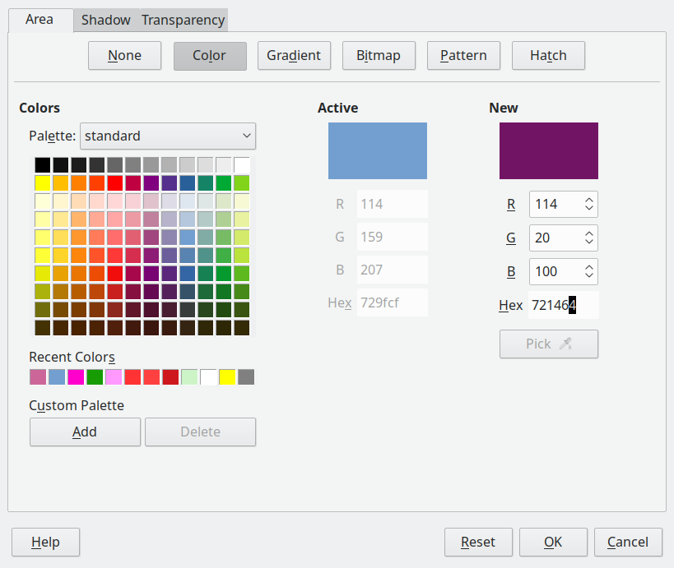

Evolving DIBs, ICM and Beyond:

Microsoft continued to refine DIBs in subsequent versions of Windows.

Windows 95/NT 4.0 introduced Image Color Management (ICM), allowing DIBs to specify precise color requirements beyond the limitations of the display device. This further enhanced color accuracy and ensured consistent visuals across different hardware configurations.

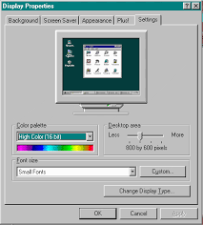

Legacy and the Modern Approach:

Despite the rise of DIBs, the older GDI bitmaps remain relevant. Understanding the concept of "bit-block transfer" and how these legacy objects interact with the GDI system is still crucial for working with bitmaps effectively.

Mastering the Bitmap Landscape:

So, how do you navigate this rich tapestry of GDI bitmap formats and functionalities?

Approaching the material chronologically, starting with basic GDI bitmaps and then progressing to DIBs and ICM, provides a strong foundation.

This historical context helps you appreciate the evolution of bitmap support and master the diverse tools available for manipulating and displaying images in Windows.

Remember, the world of GDI bitmaps is vast and rewarding to explore.

With the right knowledge and tools, you can unlock the potential to create stunning visuals, enhance user experiences, and push the boundaries of bitmap manipulation in your Windows applications.

THE BITBLT: A POWERFUL PIXEL MOVER AND MASTER OF THE VISUAL ARENA

In the realm of bitmaps, the BitBlt function reigns supreme. Pronounced "bit blit," this powerful tool stands for "bit-block transfer," and its capabilities go far beyond simply copying pixels.

Let's delve into the origins, functionality, and magic of BitBlt, your ultimate guide to manipulating and mastering the visual landscape.

From Assembly Language to Visual Revolution:

The BitBlt's story starts with the DEC PDP-10, a powerful computer of the past. In its assembly language, the BLT instruction facilitated efficient memory block transfers.

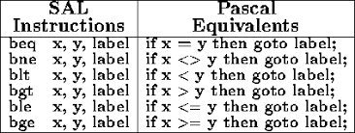

This concept of rapid movement found its way into the world of graphics through the SmallTalk system, where all graphic operations revolved around the BitBlt.

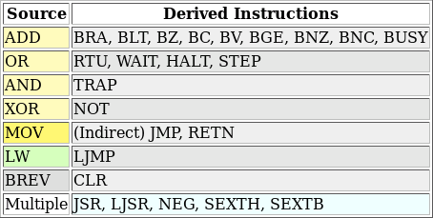

Programmers even adopted "blt" as a verb, a testament to its fundamental role in visual creation.

Beyond Transfer: A Pixel Transformer:

Calling BitBlt a mere "transfer" would be an understatement. It's not just a copy-paste tool; it's a pixel surgeon, a visual alchemist. BitBlt performs bitwise operations on pixels, allowing for a range of effects:

Simple Copying: The most common use, BitBlt can efficiently copy rectangular areas of pixels from one location to another.

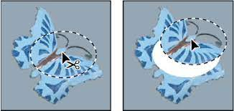

Transparency and Masking: By manipulating specific bits, you can achieve transparency, allowing underlying pixels to peek through or create intricate masks for selective blending.



Color Transformations: BitBlt can be used to alter the color palette of pixels, apply filters, and adjust brightness or contrast, transforming the visual landscape at will.

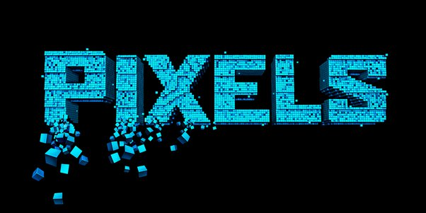

Custom Effects: With deeper understanding, you can unlock a world of creative possibilities. Imagine mirroring images, rotating them, or even blending multiple bitmaps in real-time – BitBlt makes it possible.

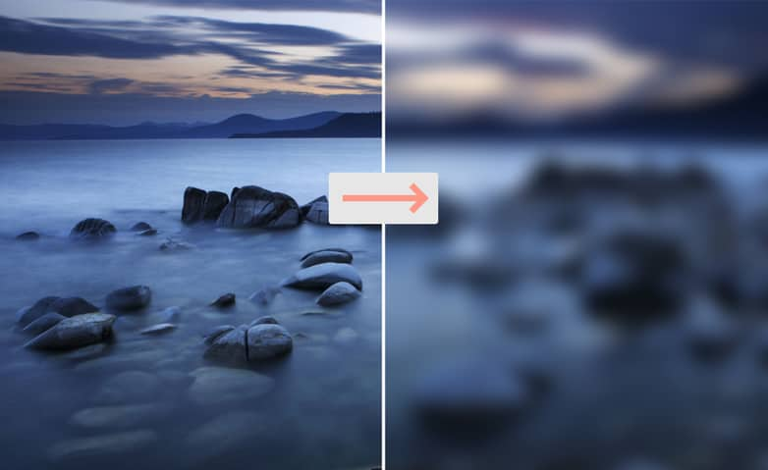

A Simple BitBlt in Action:

The BITBLT program in Figure 14-1 demonstrates a basic use case. It copies the program's system menu icon, located at the top left corner of the window, to its client area.

This simple line of code showcases the power of BitBlt – a single function call effortlessly moves a visual element within the application's window.

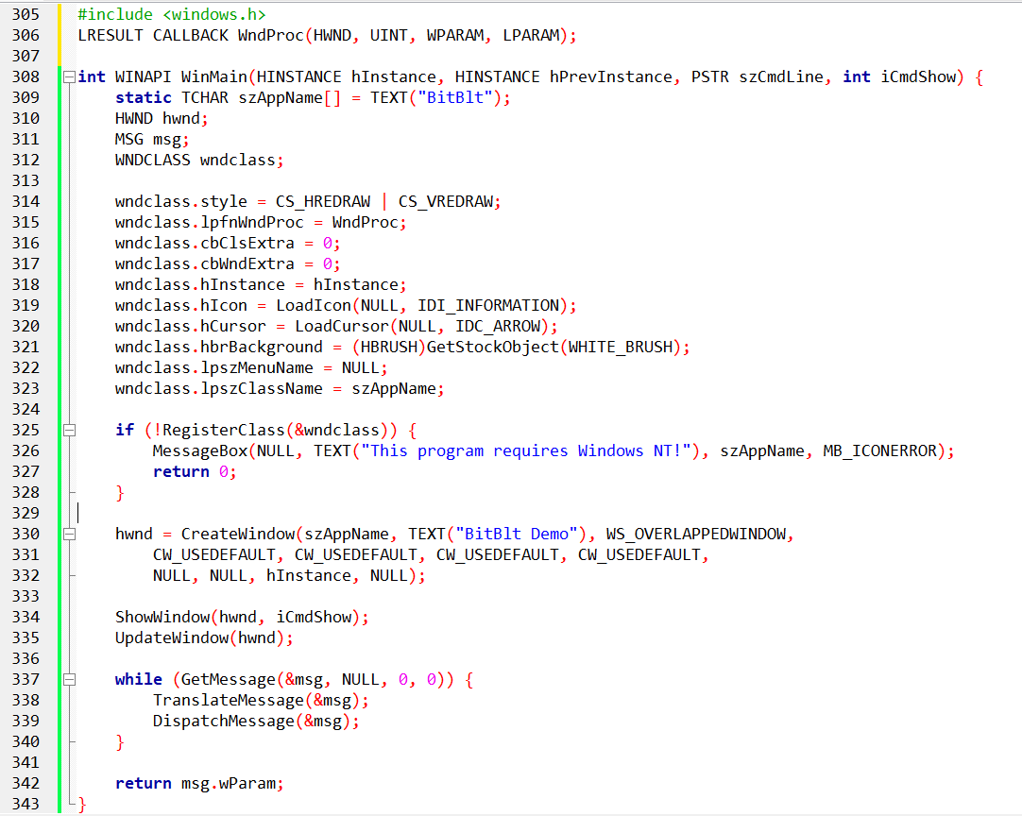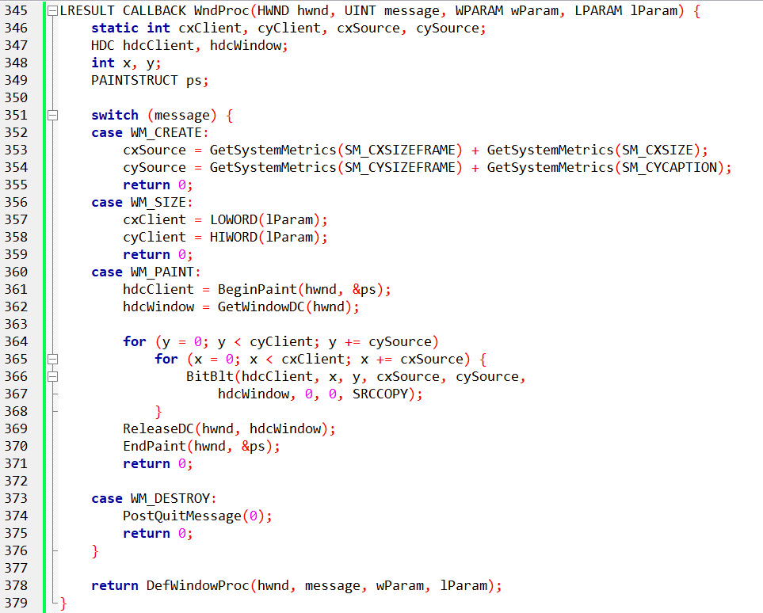

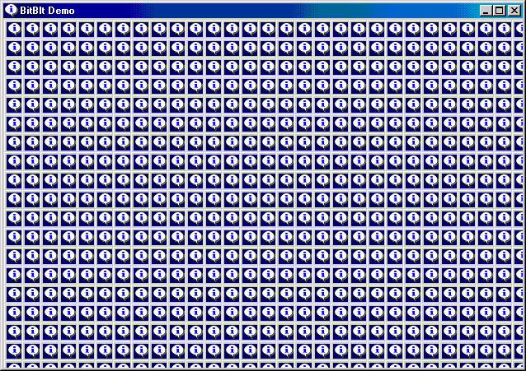

Mastering the BitBlt:

The BitBlt function offers a vast toolbox for manipulating and creating stunning visuals. To fully harness its potential, here are some key tips:

* Understand the parameters: BitBlt requires specific parameters like source and destination rectangles, color modes, and desired operations. Learning these parameters unlocks the full range of the function's capabilities.
* Explore different modes: BitBlt offers various modes like AND, XOR, and OR, each affecting how pixels are combined and transformed. Experimenting with these modes opens doors to creative effects and visual trickery.
* Combine with other tools: BitBlt is just one piece of the puzzle. Combine it with other graphical functions, drawing routines, and user interaction to create interactive and dynamic visual experiences.

The BITBLT.C code is a fascinating demonstration of the power and potential of the BitBlt function. Let's take a line-by-line tour to fully grasp its intricacies:

Header Files and Function Prototypes:

* The code includes the windows.h header file, providing access to essential Windows API functions.
* WndProc and WinMain function prototypes are declared, defining their parameters and return values.

Global Variables and Window Class Registration:

* szAppName: Stores the window's name, displayed in the title bar and used for internal references.
* hwnd: Holds the handle of the main window created by the program.
* msg: A structure containing information about Windows messages received by the program.
* wndclass: A structure defining the window class properties, including its style, window procedure, and appearance.
* RegisterClass registers the window class with the Windows system, allowing the program to create instances of the defined window type.

WinMain Function:

* Initializes the window class with desired attributes like redrawing behavior, background color, and window procedure.
* Checks for successful registration using RegisterClass. If unsuccessful, displays an error message and exits.
* Creates the main window using CreateWindow with specified title, style, and initial position.
* Shows the window using ShowWindow and updates the window content with UpdateWindow.
* Enters the main message loop, retrieving and processing messages from the system until the program exits.
* Translates and dispatches each message to the appropriate handler function.
* Finally, returns the message's wParam value upon program termination.

WndProc Function:

Handles various messages sent to the window.

* WM_CREATE: Initializes variables for source and client area sizes based on system metrics.
* WM_SIZE: Updates client area dimensions based on the window resize event.
* WM_PAINT: Performs the core BitBlt operation:
* Begins painting the window client area using BeginPaint.
* Obtains a handle to the client and window DCs (device contexts) for drawing.
* Loops through the client area in steps determined by source dimensions (cxSource, cySource).
* Inside the loop, uses BitBlt to copy a rectangular area from the window DC (source) to the client DC (destination) at specific coordinates (x, y).
* The SRCCOPY mode ensures the source pixels are directly copied to the destination.
* Releases the window DC and ends painting the client area.
* WM_DESTROY: Sends a quit message to terminate the program.
* Handles other messages like default window procedures using DefWindowProc.

Key Points to Understand:

* The program continuously copies the window content (source) to its client area (destination) using a series of BitBlt calls.
* The source dimensions are determined based on system metrics, creating a "tiled" effect within the client area.
* The loop iterates through the client area, ensuring the entire window content is copied.
* Different BitBlt modes like XOR or OR could be used for more complex visual effects.

BitBlt Syntax:

The BitBlt function transfers pixels from a source rectangle in one device context (DC) to a destination rectangle in another.

Its syntax breakdown:

* hdcDst: Handle to the destination DC (e.g., window client area)
* xDst, yDst: Coordinates of the destination rectangle's upper left corner
* cx, cy: Width and height of the rectangle to be copied
* hdcSrc: Handle to the source DC (e.g., entire window)
* xSrc, ySrc: Coordinates of the source rectangle's upper left corner
* dwROP: Raster operation (determines how pixels are combined)

Understanding the Source and Destination:

In the BITBLT program, both DCs refer to the same physical display, but their coordinate origins differ.

* hdcClient: Origin at the upper left corner of the client area
* hdcWindow: Origin at the upper left corner of the entire window

Source and Destination Positioning:

* xSrc and ySrc are set to 0, implying the entire window content is the source image.
* xDst and yDst are varied to copy the image multiple times at different positions within the client area.

Raster Operations (dwROP):

* This argument defines how source and destination pixels are blended or combined.
* The program uses SRCCOPY, which simply copies the source pixels over the destination.
* Other ROPs like XOR or OR enable various transparency and visual effects.

Important Notes:

* BitBlt transfers actual pixels from video memory, not a separate image buffer.
* Moving the window can cause incomplete image copying if part of the source falls off-screen.
* Both DCs must be compatible (either monochrome or same number of bits per pixel).

Alternative BitBlt Implementation:

* The provided code snippet demonstrates a different approach for achieving the same effect.
* It avoids repeated copying by checking if the destination point is not the upper left corner.

Further Exploration:

* Experiment with different source dimensions and loop patterns to observe how the copied content changes.
* Try modifying the BitBlt mode parameter to see how it affects the visual output.
* Combine BitBlt with other drawing functions like lines or rectangles to create more intricate visuals.

The BitBlt is more than just a function; it's a gateway to a world of visual possibilities. By understanding its origins, exploring its capabilities, and practicing its application, you can unlock the power to manipulate, transform, and create stunning visuals within your Windows applications. So, grab your pixel brush, embrace the BitBlt, and start painting your own masterpiece on the digital canvas!

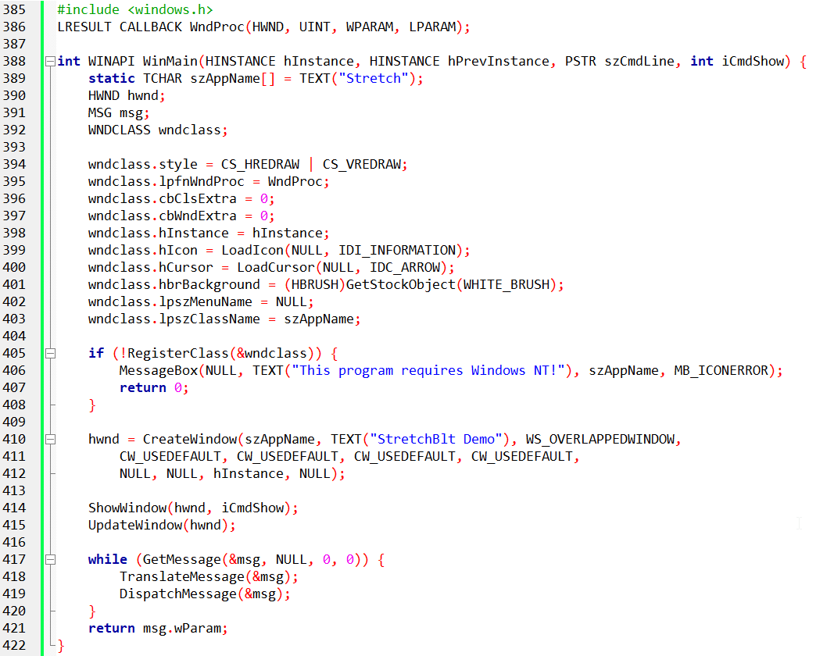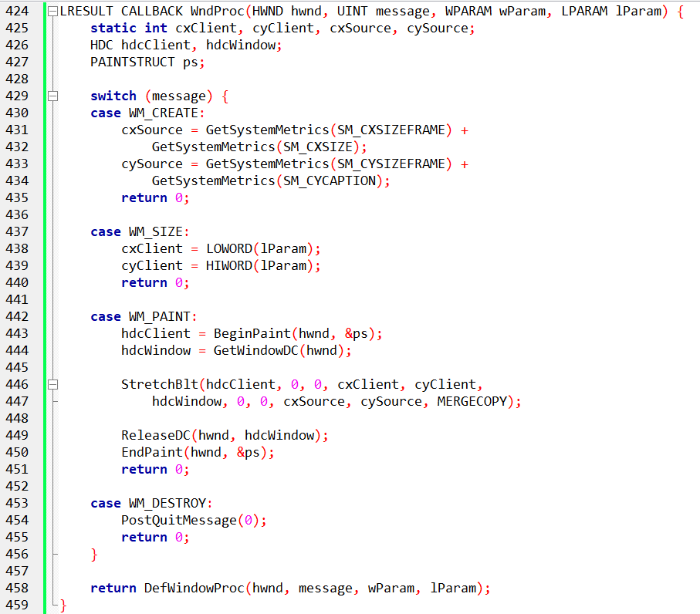

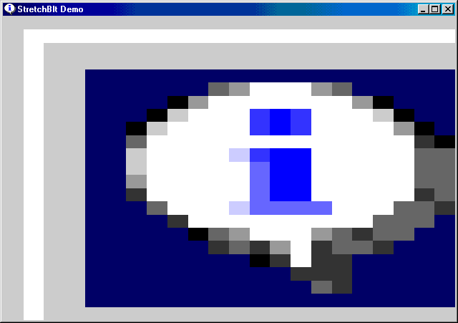

MASTERING THE STRETCHBLT FUNCTION: STRETCHING AND COMPRESSING IMAGES WITH POWER

The BitBlt function, while powerful, limits you to copying images of the same size. But what if you want to stretch or compress an image while copying it? Enter StretchBlt, a versatile tool for manipulating image dimensions on the fly. Let's delve deep into its syntax and operation, inspired by the STRETCH program:

StretchBlt Syntax Breakdown:

hdcDst, xDst, yDst, cxDst, cyDst: Destination device context handle, coordinates of the destination rectangle's upper left corner, and desired width and height of the destination rectangle.

hdcSrc, xSrc, ySrc, cxSrc, cySrc: Source device context handle, coordinates of the source rectangle's upper left corner, and original width and height of the source image.

dwROP: Raster operation code, defining how source and destination pixels are combined (e.g., MERGECOPY for smooth blending).

STRETCH Program Analysis:

The program uses StretchBlt only once, but it fills the entire client area with the system menu icon.

The destination rectangle (cxClient, cyClient) spans the entire client area, stretching the source image to fit.

The source rectangle (cxSource, cySource) represents the original size of the system menu icon.

MERGECOPY as the ROP ensures smooth blending of pixels during the stretch.

Understanding the Stretch:

StretchBlt scales the source image to fit the specified destination dimensions.

It can stretch or compress the image proportionally or non-proportionally depending on the chosen destination rectangle.

Imagine stretching a rubber sheet – the image content gets warped and distorted as the dimensions change.

Beyond the Basics:

Experiment with different destination rectangle sizes to see how the image stretches or compresses.

Try other ROPs like SRCCOPY (simple copying) or XOR (transparent blending) to observe different visual effects.

Combine StretchBlt with other drawing functions to create visually complex compositions.

StretchBlt Advantages:

Offers flexibility in manipulating image size during copying.

Enables creative effects like stretching backgrounds or zooming into images.

Provides a powerful tool for building interactive user interfaces with dynamic visuals.

Limitations to Remember:

Stretching can distort or blur the image, impacting quality.

Scaling beyond certain limits might lead to unwanted artifacts or pixelation.

Be mindful of compatibility between source and destination DCs.

Stretching Your Horizons:

Mastering StretchBlt unlocks a world of possibilities for manipulating and presenting images in your Windows applications. Remember:

* Practice with different parameters and ROPs to unlock creative visual potential.
* Be mindful of potential quality loss when stretching images.
* Combine StretchBlt with other tools and techniques for a richer visual experience.